CONFIDENTIAL CS/OCT 2026/MAT133

UNIVERSITI TEKNOLOGI MARA FINAL EXAMINATION

COURSE
COURSE CODE
EXAMINATION TIME
PRE CALCULUS
MAT133 OCTOBER 2026
2 HOURS

INSTRUCTIONS TO CANDIDATES

- This question paper consists of 5 questions.

- Answer ALL questions in the Answer Booklet. Start each answer on a new page.

- Do not bring any material into the examination room unless permission is given by the invigilator .
- Please check to make sure that this examination pack consists of: i) the Question Paper
  - a one - page Append ix 1
  - an Answer Booklet - provided by the Faculty
  - a graph paper - provided by the Faculty

- Answer ALL questions in English.

/

DO NOT TURN THIS PAGE UNTIL YOU ARE TOLD TO DO SO

This examination paper consists of 6 printed pages

QUESTION 1
a) Write the solution of 4 - 4x < -6 in interval notation and on a number line.
(3 marks)
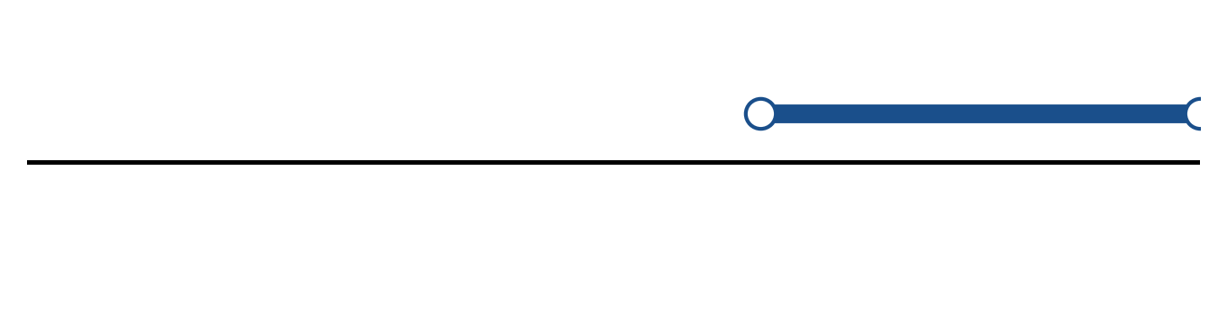
Figure: solution set.
b) Solve the inequality |2x - 2| < 4. Express the answer in interval notation and on a number line.
(5 marks)
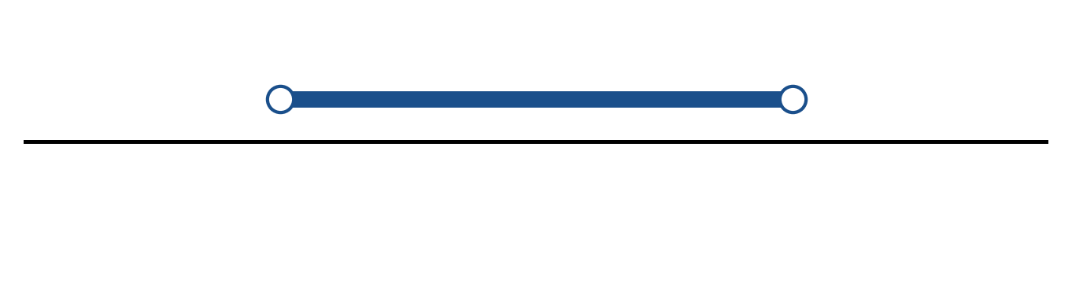
Figure: solution on a number line.
c) Solve the equation |-2x - 3| = 8.
(4 marks)
QUESTION 2
a) Given f(x) = (3 - 3x)/(4x + 4), x ≠ -1, find f⁻¹(x) and state its domain.
(5 marks)
b) The piecewise function is defined by
f(x) = -2x - 1, if x < -1;
f(x) = 1, if -1 ≤ x ≤ 2;
f(x) = x² - 2, if x > 2.
Sketch the graph and find f(-2), f(0) and f(3).
(5 marks)
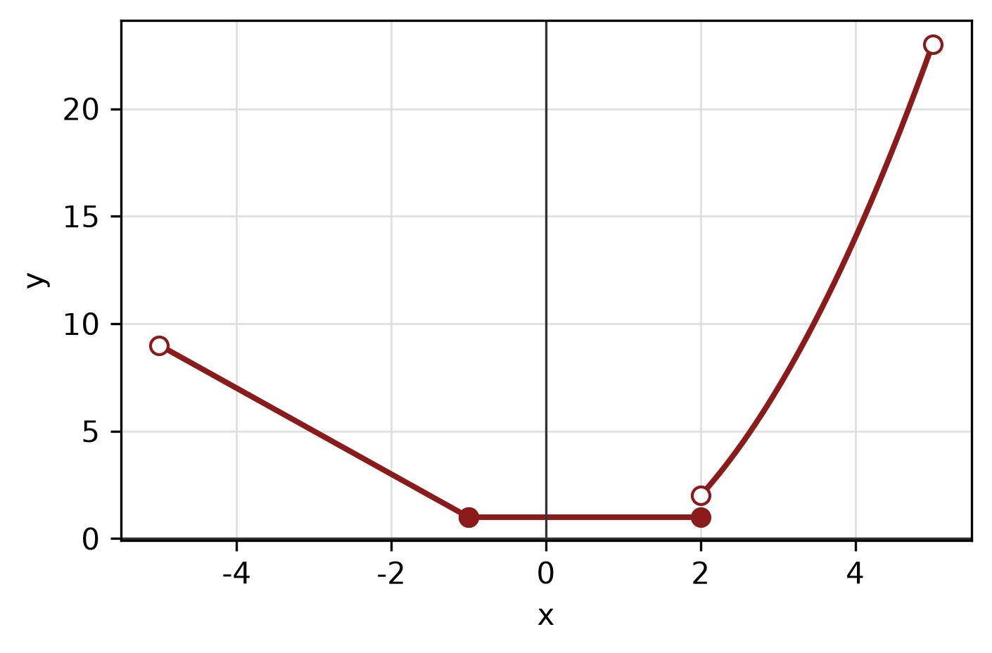
Figure: piecewise graph.
c) Sketch the circle x² + 6x + y² - 8y = 0. State its centre and radius.
(4 marks)
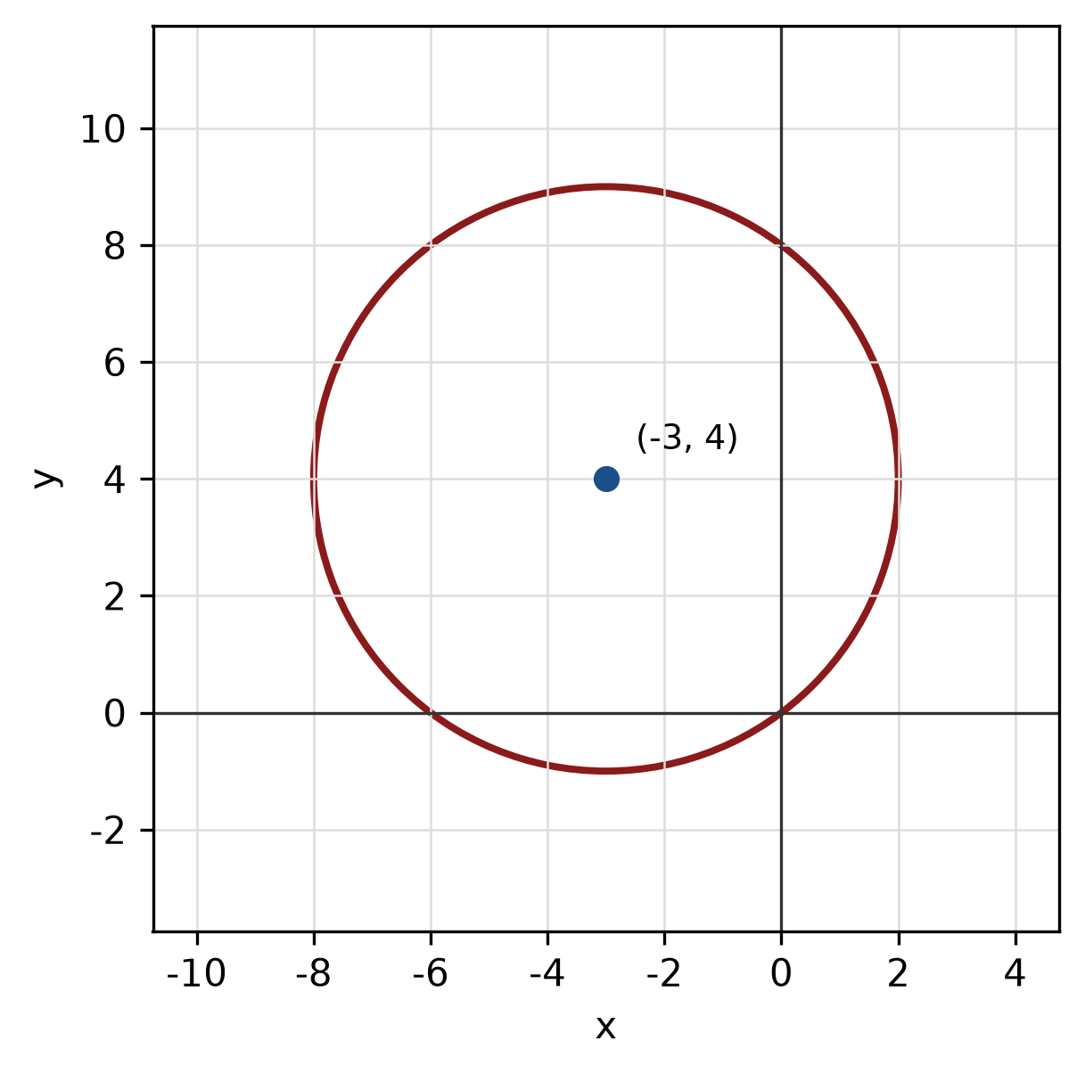
Figure: circle.
QUESTION 3
a) Given z₁ = -5 + 3i and z₂ = -1 + 5i, express z₁/z₂ in the form a + bi.
(5 marks)
b) Find the modulus and argument of z = -8 + 15i. Give the argument in degrees correct to one decimal place.
(5 marks)
c) Use long division to find the quotient and remainder when f(x) = -2x^3 + 5x² - 2x - 5 is divided by x.
(5 marks)
QUESTION 4
a) Solve the simultaneous equations
y = x² + 4
y = 7 - 2x.
(5 marks)
b) Write a system of inequalities that describes the shaded triangular region with vertices (0, 0), (4, 0) and (0, 5).
(5 marks)
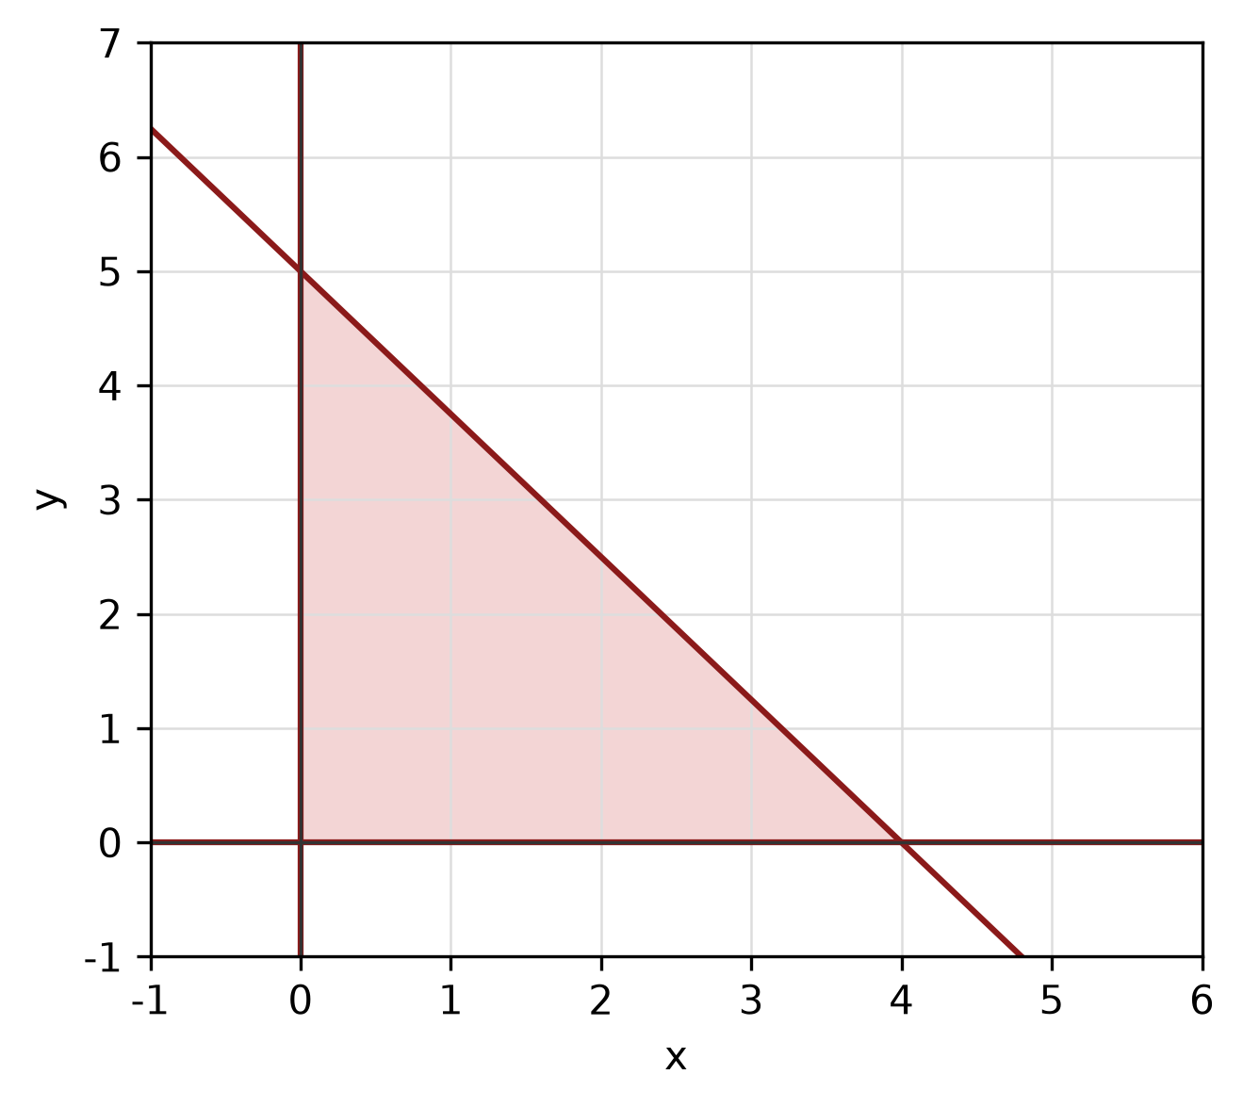
Figure: shaded triangular region.
c) Write the equation of the circle with centre (-1, 1) and radius 2. Hence write its general equation and sketch the circle.
(5 marks)
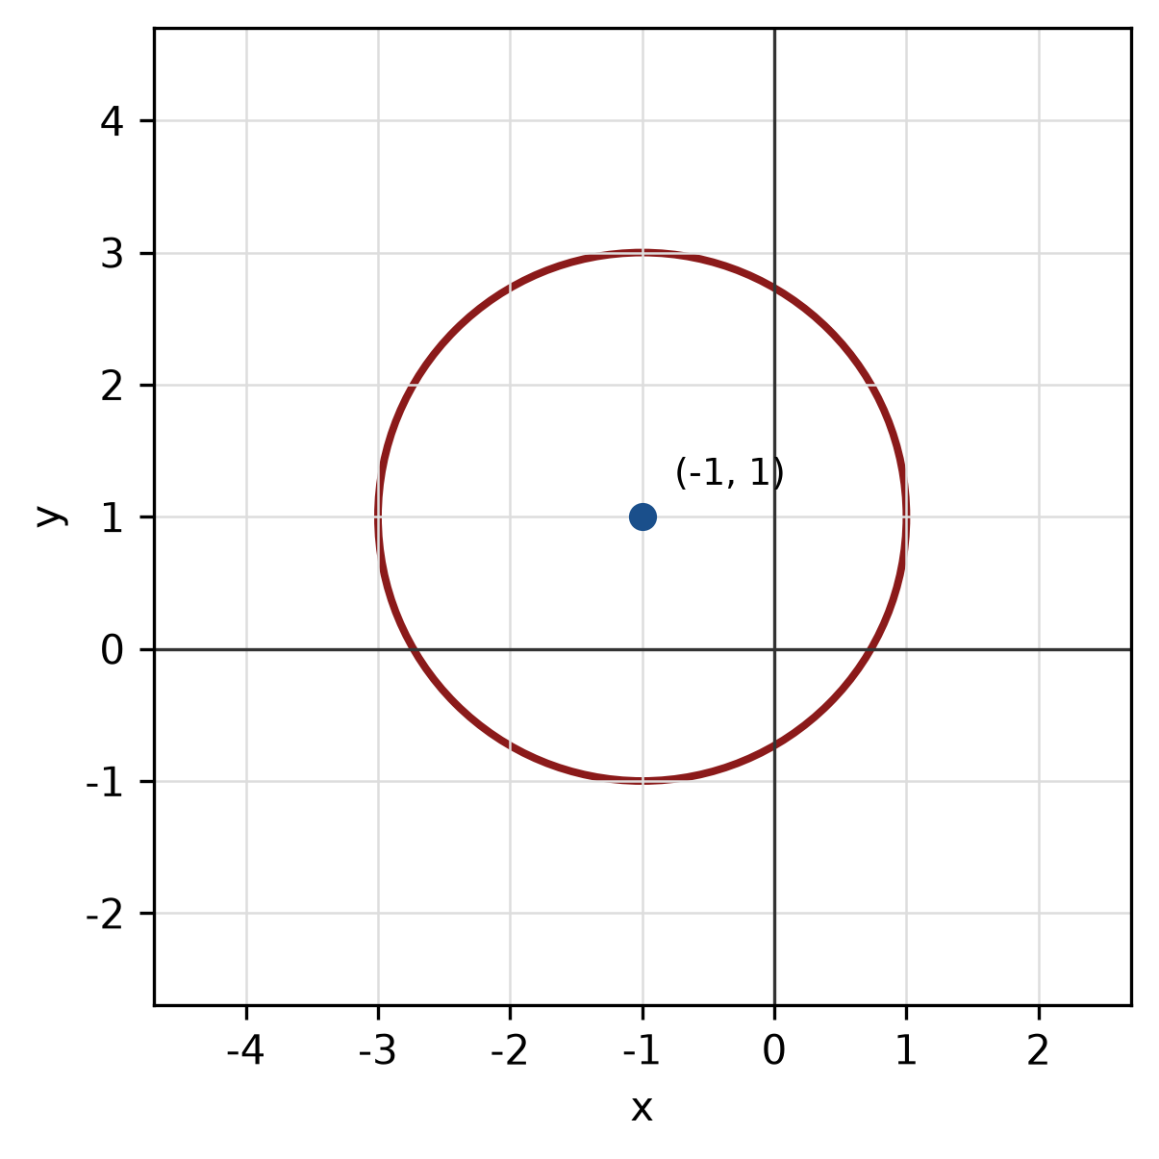
Figure: circle.
QUESTION 5
a) Given sin A = 5/13 where A is in quadrant II and cos B = 12/13 where B is in quadrant IV, find sin 2A and cos(A + B).
(5 marks)
b) Find the perimeter of the sector with radius 11 cm and central angle 45°.
(4 marks)
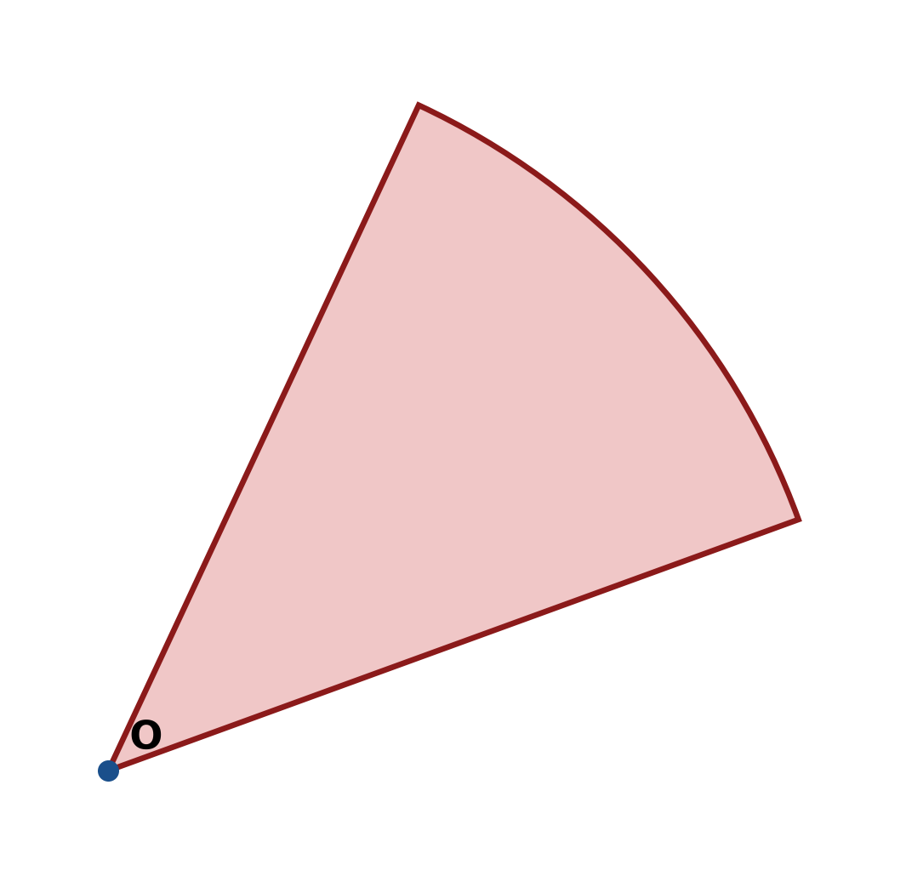
Figure: sector.
c) In triangle ABC, b = 8 cm, c = 12 cm and A = 60°. Use the cosine rule to find a.
(4 marks)
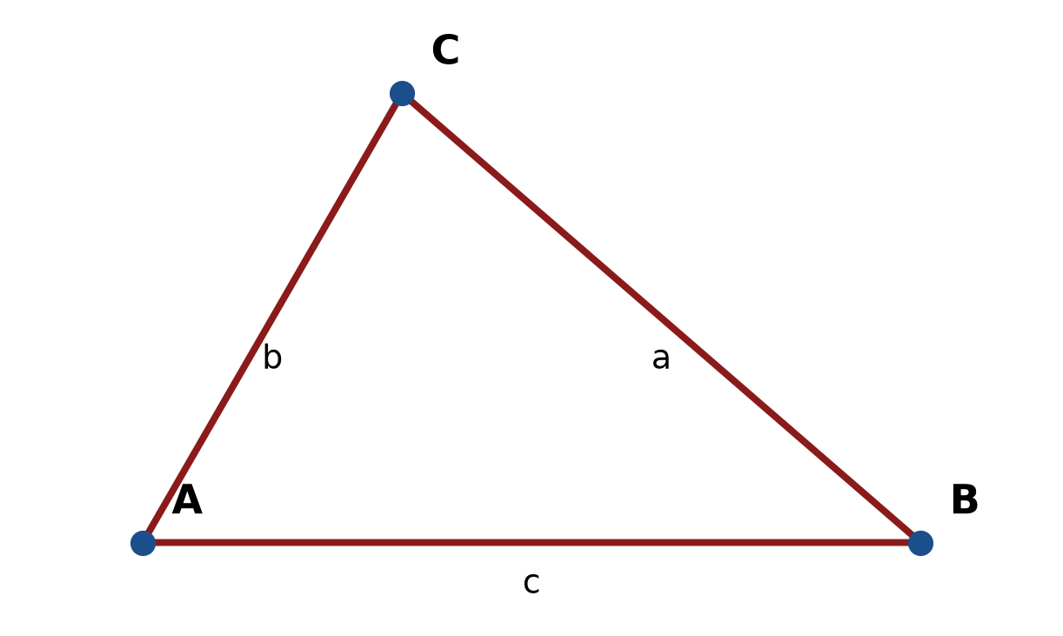
Figure: triangle ABC.
END OF QUESTION PAPER

APPENDIX 1
Formula sheet (as supplied with the paper).
sin² A + cos² A = 1 | tan² A + 1 = sec² A
sin(A + B) = sin A cos B + cos A sin B | tan 2A = 2 tan A / (1 − tan² A)
cos(A + B) = cos A cos B − sin A sin B | Arc length, s = rθ
tan(A − B) = (tan A − tan B) / (1 + tan A tan B) | Area of sector = ½r²θ
cos 2A = cos² A − sin² A | a / sin A = b / sin B = c / sin C
cos 2A = 1 − 2sin² A = 2cos² A − 1 | a² = b² + c² − 2bc cos A
sin 2A = 2 sin A cos A | Area of triangle = ½ab sin C

